Who We Are
- Spirit Lake Consulting is a new generation of Indian-owned businesses
- Spirit Lake Consulting is located on Spirit Lake Nation an Indian reservation in North Dakota and serves Native American clients
- Spirit Lake Consulting has the cultural knowledge and expertise needed to work on Indian reservations
Spirit Lake Consulting offers workshops developed with the purpose of making better lives through education for tribal members with disabilities and chronic illness.

Spirit Lake Consulting

If you are interested in attending any of these courses, please contact our reservation headquarters.

“Making Life Better”
An Indian-owned business

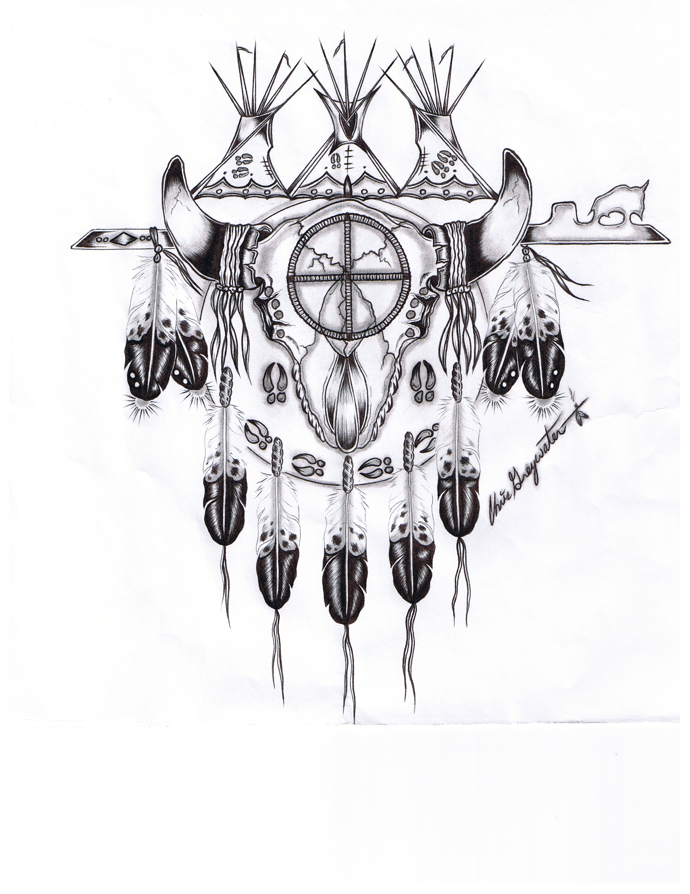

Secondary Heading
The most important information is included here on the inside panels. Use these panels to introduce your organization and describe specific products or services. Ts text should be brief and should entice the reader to want to know more about the product or service.
You can use secondary headings to organize your text to make it more understandable to the reader.
Spirit Lake Consulting
www.spiritlakeconsulting.com
314 Circle Dr. PO Box 663
Fort Totten, ND 58335
Phone: 701-351-2175
Fax: 800-905-2571Email: info@spiritlakeconsulting.com
Reservation Headquarters
Spirit Lake Nation
Dr. Erich Longie, President
314 Circle Dr. PO Box 663
Fort Totten, ND 58335
(701) 351-2175
Fax (800) 905-2571
ericstev@
spiritlakeconsulting.com

California Office
Dr. AnnMaria DeMars,
Vice-President
2111 7th St. #8
Santa Monica, CA 90405
(310) 717-9089
Fax (310) 496-2068
annmaria@
spiritlakeconsulting.com

www.spiritlakeconsulting.com

COPT Workshop Series
The Caring for our People Training, is aimed at training professional staff and educating community members who work with people who are disabled . Even experienced staff members may find new information here.
The Caring for Our People Training series consist of four modules:
Module 1 Introduction to Disability & Culture: helps parents and students with disabilities with the problems they will face in and out of school. This includes dealing with special education, balancing a social life, attending IEP meetings, and practicing a healthy lifestyle.
Module 2 - Early Childhood - this module introduces important concepts in early intervention, such as Individual Service Family Plans, classroom modifications in preschool, developmental stimulation, behavior disorders in young children, and personal care

Family Life Series
Family Life contains three modules:
Module 1 - Empowering Ourselves and Our Families: focuses on the services available to people with disabilities, their rights, and how to find just about anything you need to know by using the Disability Access CD-ROM, which you will receive for free.
Module 2 - Family Life and Disability - provides information and solutions to common problems for people with disabilities and their families. These include coping with diagnosis, behavior problems, becoming independent, substance abuse, and sexuality.
Module 3 - Adulthood and Aging – a workshop geared towards elders and those who care for them. We face issues such as adjusting to a disability after a lifetime of independence, accepting care, making sure you get the care you or a family member needs, death, dying, and living as healthily as possible.

COPT Workshop Serie

Module 3 - Special Education – this course module is a must for parents and educators alike, as it focuses on educational, personal and social issues for school age children with disabilities.

Module 4 – Adolescents & Adults with Special Needs - covers the services and information needed to help people with disabilities get and keep jobs. This workshop is aimed at helping young people become independent. We discuss finding employment, leaving home, relationships, self-advocacy, and finding mentors and others who will help you succeed. We also address the difficult issues in parenting youth with disabilities

